Geometry: Unit 11, Lesson 9
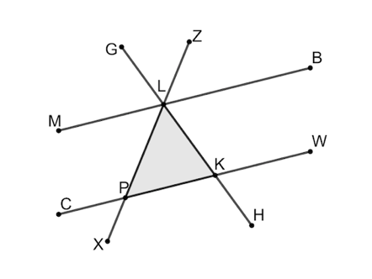
- Parallel line segments $MB$ and $CW$ are shown, with transversals $\overline{GH}$ and $\overline{ZX}$ creating $∆PKL$. What is the value of $m∠PLK+m∠LKP+m∠KPL$?

$$180°$$

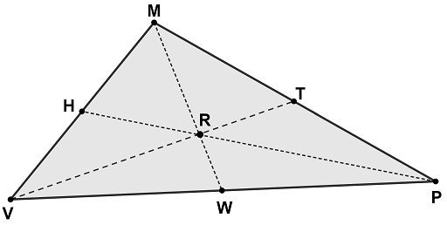
- Triangle $MPV$ is shown, where point $R$ is the centroid of the triangle. Is the statement $\frac{VW}{VP}=\frac{1}{2}$ true?

Yes
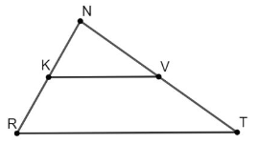
- Triangle $RNT$ is shown, where point $K$ is the midpoint of $\overline{RN}$, and point $V$ is the midpoint of $\overline{NT}$. Is the statement $∠NKV≅∠NRT$ true or false?

True

